Project Design Phase-II
Solution Requirements (Functional & Non-functional)

Date | 20 February 2026
Team ID | LTVIP2026TMIDS35897
Project Name | BookNest : Where stories nestle
Maximum Marks | 4 Marks

Functional Requirements:
Following are the functional requirements of the proposed solution.
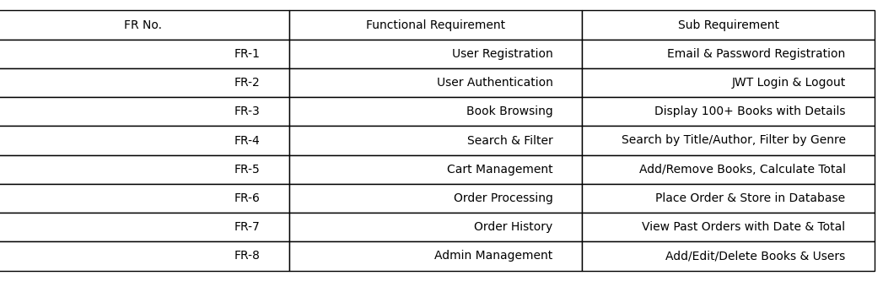
Non-functional Requirements:
Following are the non-functional requirements of the proposed solution.
